**Technology Design Project – COS 60011**

**Deliverable 1**

**Individual Research Report**

**Name:** Arun Ragavendhar Arunachalam Palaniyappan

**Student ID:** 104837257

**Tutorial:** Monday AGSE 108 04:30 PM – 06:30 PM

Contents

Acknowledgement to Country 3

1. Introduction 3

2. Machine Learning and Neural Networks 3

2.1 Understanding Machine Learning 3

2.2 Introduction to Neural Networks 3

3. Deep Feedforward MLP with Backpropagation 4

3.1 Understanding the Deep Feedforward MLP 4

3.2 Backpropagation 5

3.3Mathematical Representation of the Model 5

3.3.1. Forward Pass Equation 5

3.3.2. Loss Function (Cross-Entropy Loss) 6

3.3.3. Gradient Descent Update Rule 6

4. Implementation in the Car Recommendation System 7

4.1 Dataset Preparation 7

4.3 Method of Implementation 7

5. Summary and Conclusion 7

7. References 7

8.Appendix 8

8.1 List of Figures 8

# Acknowledgement to Country

The contemporary day Melbourne and Swinburne University of Technology are located in what was once known as the Kulin Nation. As a Swinburne student who is deeply thankful and happy to be studying at this prestigious university, I would want to sincerely express my respects to the Wurundjeri People of this nation, who are the traditional proprietors of these lands. In addition, I gratefully acknowledge Swinburne's Aboriginal and Torres Strait Islander students, alumni, partners, and guests. It is an honour and a source of pride for me to recognise and appreciate the spirituality, history, and culture of this location with the Wurundjeri land.

# 1. Introduction

Machine learning (ML) is a groundbreaking method that allows computers to learn from data and make judgements without requiring explicit programming. Many current applications rely on machine learning, particularly recommendation algorithms, which are critical in directing user choices across a wide range of areas, from movies and books to products and services.

This report focuses on the learnings and knowledge acquired through research, for the implementation of a car recommendation system using a Deep Feedforward Neural Network, also known as a Multi-Layer Perceptron (MLP). The report will cover the basics of machine learning and neural networks, delve into the specifics of deep MLPs and backpropagation, and outline the steps involved in implementing this model in a recommendation system.

# 2. Machine Learning and Neural Networks

## 2.1 Understanding Machine Learning

Machine learning is a subset of artificial intelligence (AI) in which algorithms use data to generate predictions or judgements. The major objective is to enable computers to automatically detect patterns in data and improve over time. There are three primary forms of machine learning:

• **Supervised Learning:** The model is trained using labelled data with known input-output pairings. The goal is to learn a mapping of inputs to outcomes.

• **Unsupervised learning:** This involves training models on unlabelled data to find patterns or groups.

• **Reinforcement learning:** The model learns through interactions with its surroundings, receives feedback, and improves its performance.

For the proposed project, supervised learning is to be used to predict car recommendations based on user preferences and requirements.

## 2.2 Introduction to Neural Networks

Neural networks are computer models that draw inspiration from the structure and function of the human brain. They are made up of layers of linked nodes, or neurones, that process information via a network of weighted connections.

Figure 1: Basic Structure of a Neural Network

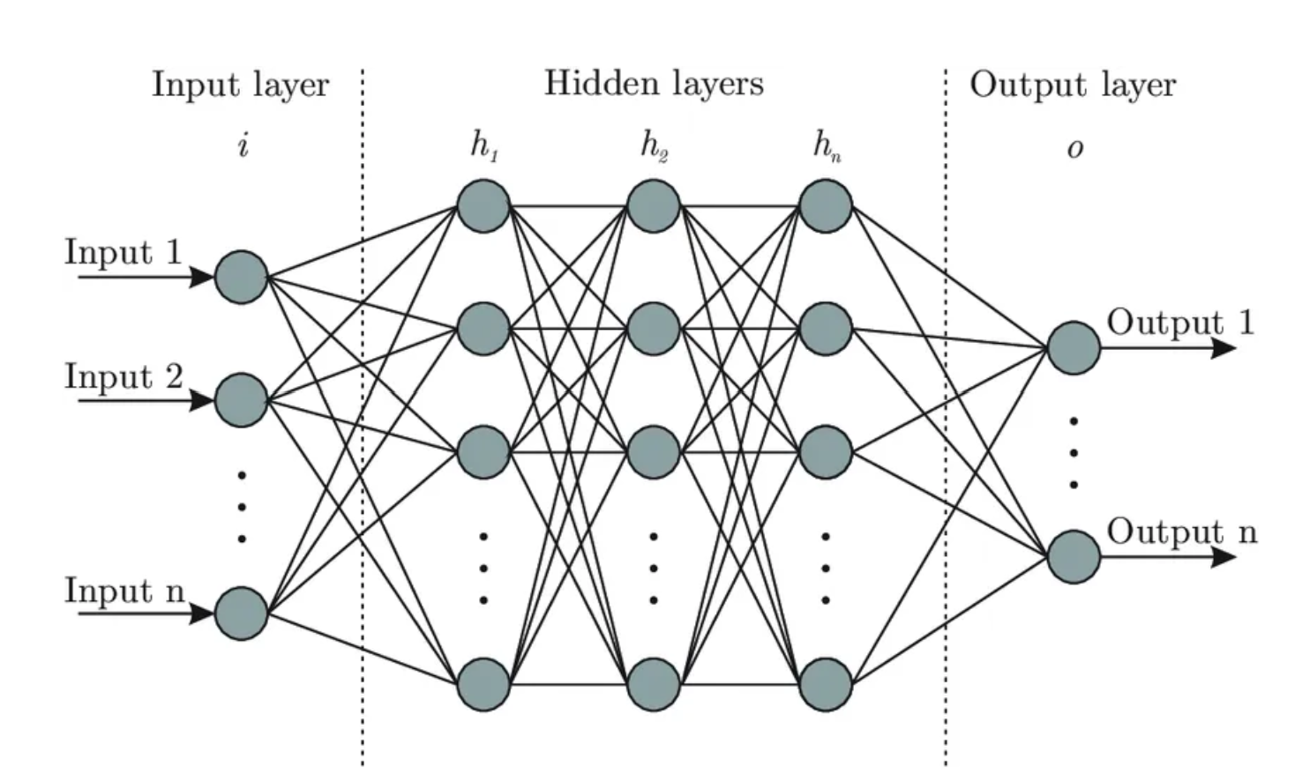

• The **input layer** receives raw data characteristics (such as automobile attributes).

• **Hidden layers** are intermediate levels where data undergoes complicated changes. The network becomes deeper as the number of hidden levels increases.

• The **output layer** generates the ultimate result, in this example, automobile suggestions.

Each connection between neurons has an associated weight, and each neuron has an activation function that determines whether it should "fire" or pass on its signal. The learning process involves adjusting these weights to minimize the difference between the predicted output and the actual target.

# 3. Deep Feedforward MLP with Backpropagation

## 3.1 Understanding the Deep Feedforward MLP

A Deep Feedforward MLP is a neural network in which the connections between neurones do not generate cycles. Data travels in a single direction: from the input layer to the output layer, via numerous hidden layers. The network's depth (the number of hidden layers) enables it to detect complicated patterns in the data.

Figure 2: Deep Feedforward MLP Architecture

In a car recommendation system, the input layer may include information such as automobile body type, budget, and fuel economy. The hidden layers combine these features to provide the most appropriate automobile suggestions in the output layer.

## 3.2 Backpropagation

Backpropagation is a technique used to train deep neural networks. It comprises two primary phases: forward pass and backwards pass.

**Forward Pass:** The input data is sent through the network layer by layer until it reaches the output layer, when a prediction is formed.

**Backwards Pass:** The error between the expected and actual outputs is determined. This mistake is then transmitted back across the network, and the weights are changed to reduce the error.

The backwards pass is based on a mathematical concept known as gradient descent, which seeks a function's minimum by iteratively travelling in the direction of steepest fall.

## 3.3Mathematical Representation of the Model

### 3.3.1. Forward Pass Equation

**Equation:**

**Explanation:**

* **(Predicted Output):** This is the output predicted by the model, also called the model's prediction.
* **(Weights Matrix):** In a neural network, each input feature is multiplied by a weight. The weights determine the importance of each input feature in making predictions.
* **(Input Features):** This represents the features or data points that are input into the model. For instance, if you're predicting house prices, these could be the size of the house, the number of rooms, etc.
* **(Bias Term):** This is a constant that allows the model to fit the data better by shifting the activation function.
* **(Activation Function):** This function applies a non-linear transformation to the input. Common activation functions include:
  + **(Rectified Linear Unit):** Outputs zero if the input is negative and outputs the input itself if it's positive.
  + **:** Squeezes the input into a range between 0 and 1.

**How it works:**

* The input features are multiplied by the corresponding weights , and the bias is added to the result. This linear combination ) is then passed through the activation function to introduce non-linearity, resulting in the predicted output .

### 3.3.2. Loss Function (Cross-Entropy Loss)

**Equation:**

**Explanation:**

* **(Loss Function):** The loss function measures the difference between the predicted output ^​ and the actual output . In machine learning, we try to minimize this loss to improve the model’s accuracy.
* **(Actual Output):** This is the true label or value that we are trying to predict.
* **​ (Predicted Output):** This is the output predicted by the model.

**How it works:**

* **Cross-Entropy Loss** is used primarily in classification problems. It quantifies how far the predicted probabilities () are from the actual labels (​).
* The equation sums over all classes . For each class , it multiplies the actual label ​). by the logarithm of the predicted probability ​)
* If the predicted probability ​) is close to the actual label ​), the loss will be small. If it's far off, the loss will be large. The goal of training is to minimize this loss.

### 3.3.3. Gradient Descent Update Rule

**Equation:**

**Explanation:**

* **(Updated Weights):** These are the new values for the weights after the update.
* **(Current Weights):** These are the weights before the update.
* **(Learning Rate):** This is a small positive value that controls the step size of the update. It determines how quickly or slowly the model learns.
* **(Gradient of the Loss with Respect to Weights):** This represents the slope of the loss function with respect to the weights. It tells us how to change the weights to decrease the loss.

**How it works:**

* **Gradient Descent** is an optimization algorithm used to minimize the loss function.
* The algorithm updates the weights in the direction that decreases the loss.
* The term ​ (the gradient) points in the direction of the steepest ascent of the loss function. By subtracting it, we move the weights in the direction of the steepest descent (hence minimizing the loss).
* The learning rate controls how large of a step we take in that direction. If is too large, it might overshoot the minimum; if it’s too small, learning will be slow.

# 4. Implementation in the Car Recommendation System

## 4.1 Dataset Preparation

The dataset for this automobile recommendation system consists of 15 characteristics and 30,000 records. These qualities include a variety of automotive characteristics, such as body style, budget, fuel economy, and brand value.

**Steps for Data Preparation:**

* **One-Hot Encoding:** Categorical variables (such as car body type, engine type, etc.) are turned into binary vectors for use as neural network inputs.
* **Normalisation** is the process of scaling numerical characteristics (for example, budget and fuel efficiency) to a common range to enhance model performance.

## 4.3 Method of Implementation

* **Data Preparation:** The dataset is pre-processed using one-hot encoding and normalisation.
* **Model Initialisation:** The deep MLP is configured with the chosen architecture.
* **Training:** The model is trained via backpropagation and gradient descent, with weights adjusted to minimise the loss function.
* **Deployment:** The trained model is incorporated into a Streamlit online application, which allows users to enter their preferences and obtain automobile suggestions.

# 5. Summary and Conclusion

This research investigated the use of a Deep Feedforward MLP in an automobile recommendation system. It defined the implementation procedures required to develop a viable recommendation engine by explaining machine learning, neural networks, and backpropagation in depth. The deep MLP's capacity to learn from complicated data and generate accurate predictions makes it an effective tool in current recommendation systems.

# 7. References

* Alpaydin, E. (2020). *Introduction to Machine Learning* (4th ed.). MIT Press.
* Bengio, Y., & LeCun, Y. (2003). Generalization in deep learning. *Journal of Machine Learning Research*.
* Bishop, C. M. (2006). *Pattern Recognition and Machine Learning*. Springer.
* Chollet, F. (2017). *Deep Learning with Python*. Manning Publications.
* Goodfellow, I., Bengio, Y., & Courville, A. (2016). *Deep Learning*. MIT Press.
* Heaton, J. (2018). *Introduction to Neural Networks with Java*. Heaton Research, Inc.
* Murphy, K. P. (2012). *Machine Learning: A Probabilistic Perspective*. MIT Press.
* Nielsen, M. A. (2015). *Neural Networks and Deep Learning: A Textbook*. Determination Press.
* Russell, S., & Norvig, P. (2021). *Artificial Intelligence: A Modern Approach* (4th ed.). Pearson.
* Sutskever, I., Martens, J., & Hinton, G. (2011). Learning with recurrent neural networks. *Proceedings of the 28th International Conference on Machine Learning*.
* Zhang, C., & Ma, Y. (2021). *Ensemble Machine Learning: Methods and Applications*. Springer.

# 8.Appendix

## 8.1 List of Figures

Figure 1: Basic Structure of a Neural Network